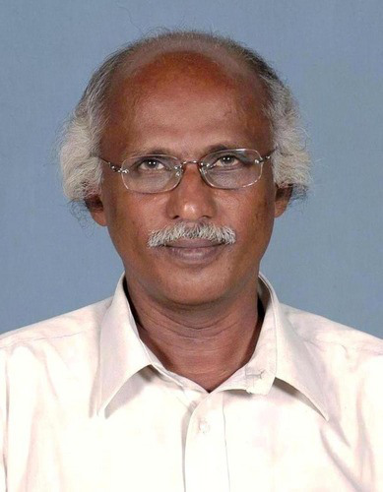

Prof. C.I Issac

Prof. C.I. Issac is an eminent historian and writter in Kerala. He was the Head of the PG Department of
History, CMS College, Kottayam, Kerala. History . Now he is Vice President, Bhartheeya Vichara Kendram.
He has a number of books and publications related to Indian Culture and History.

